**PARADE USER GUIDE**

**Plotting**

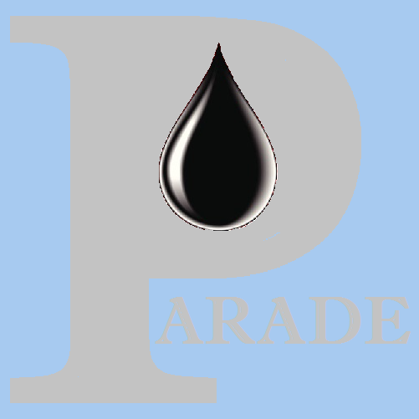

**Version 1.50 Apr 2021**

**Version History**

|  |  |  |  |
| --- | --- | --- | --- |
| **Version** | **Date** | **Author** | **Comments** |
| 1.29 | Sep 2020 | K.Wilson | Original Version |
| 1.44 | Dec 2020 | K.Wilson | Added Surge and Swab |
| 1.50 | Apr 2021 | K.Wilson | General update |

Contents

Overview 1

Path plots 1

Creating the plots 1

Path plot definition 3

Displaying Path Plots 6

Scaling 7

Depth Plots 8

Depth plot definition 10

Depth Plot Curves 12

Depth Plot Notes 13

Depth Plot Lines 14

Depth Plot Shading 15

Displaying Depth Plots 17

Scaling 18

# Overview

Parade uses plots to display Calculated data and Well paths.

These plots can be displayed on the screen, printed or saved to a bit map file or to the clipboard so they can be used in reports.

Parade does not save plots directly but has tables which define their content and recreates them as required.

These definitions are created during calculations, for calculated data and via a dialog for Well paths.

It is possible for the user to modify these plots and even create new plots directly.

# Path plots

The standard set of path plots consists of a 3d plot, a plan plot (North v East), several horizontal distance vs TVD plots and the dogleg plot which displays 4 parameters against Measured depth.

## Creating the plots

The are created by clicking on the [Gen Plots] button on the Well path table form in the Scenario Menu. There are additional buttons to display each of the plots. A similar set of buttons is available in the Tortuosity option.



This button displays the Path Plot generation dialog

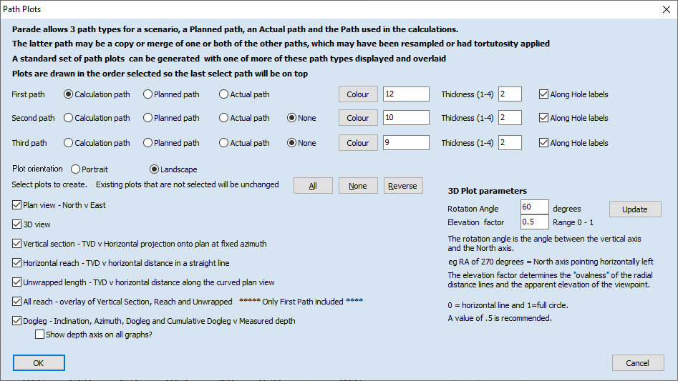

There are 3 sets of paths for each scenario. The path used in the calculations, which should have am appropriate distance between data points and include tortuosity, the Planned path which is likely to been to smooth and the actual path imported from a survey or MWD, which may have very small depth increments.

You can select which of these 3 is displayed and choose the colour and thickness of the lines used.

Along hole labels can be added to plots, other than the dogleg, which already has along hole depths as the Y axis.

The plots can be displayed in Portrait or Landscape orientation. This like many other parameters can be changed later.

You then select which plots to create, with buttons available to select/deselect multiple plots.

The dogleg plot consists of 4 Graphs of angles or doglegs against Measured depth. Usually, only one set of depth axis labels is required on the left most graph, but they can be displayed on all graphs if required.

The 3D plot viewpoint, is defined by a Rotation angle and an Elevation factor. The rotation angle defines how far the plot has been rotated in a clock wise direction from having the North axis Pointing up the page. A good initial value is 90 degrees more than the vertical section.

The elevation factor defines the apparent height of a circle versus its width, since a 3d circle is represented as an oval in 2D. The higher the factor, the higher the apparent viewpoint. A value of 0.5 is a good default.

If you change these values you can save them for future generation dialogs, using the [Update] button.

## Path plot definition

Path plots are defined in a set of 3 tables:

The path plot Header table (pplhdr.pxd) defines the plots, with the plot code as the index.

The path plot Graphs table (pplgph.pxd) defines the graphs for each plot, with the plot code and graph number as its index.

The path plot Curves table (pplcrv.pxd) defines the curves for each graph, with the plot code, graph number and curve number as its index.

These definitions can be accessed using the Path plots Option on the Graphics Menu.

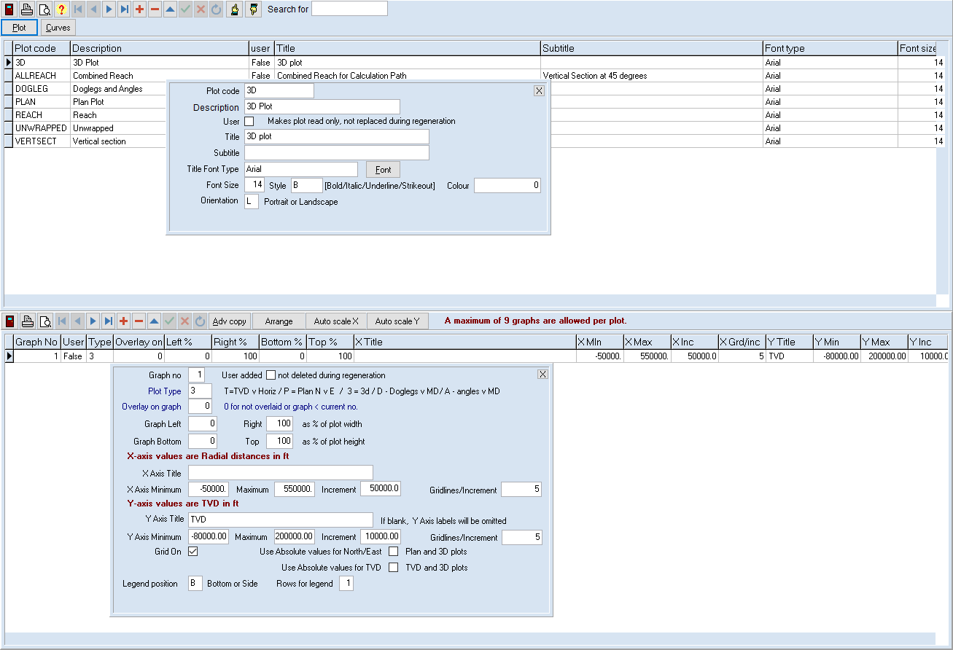

The top grid displays all the headers records. The bottom grid displays only the graphs for the plot selected in the top grid. The buttons with hands pointing up and down are used to change the size of the bottom grid.

The header table defines the plot code and its description for identifying each plot.

The title and subtitle actually appear on the plot and there are options to change the font used for the title and the orientation of the plot.

Each plot has 1 or more graphs which are defined in the lower grid.

For most plots there is a single Graph using all the plotting area.

For the Dogleg plot, 4 graphs are defined – for Inclination, Azimuth, Dogleg and Cumulative Dogleg.

Each Graph has a number , which defines the drawing order and a plot type of a single character, which defines the X and Y axis types, one of:

* T – TVD v Horizontal distance, used for Vertical section, Horizontal Reach and Unwrapped length plots
* P – Plan plots with Y axis measuring North offset and X axis measuring East offset.
* 3 – 3d plots with Y axis measuring TVD and the North and East represented by an X axis distance and a Y axis offset.
* D – Doglegs in degrees per length on the X axis and measured depth on the Y axis
* A – Angles in degrees on the X axis and measured depth on the Y axis, used for inclination, azimuth and cumulative dogleg.

It is possible to overlay graphs on top of one another by specifying the graph to overlay. (Not used by the default plots)

The X and Y axis are then defined for each graph.

The position of the graph is defined by the % of the plotting area for the left, right, top and bottom of the graph. (This includes the labels and legend)

The titles for each axis are defined as well as the minimum and maximum values for the axis and the label increments. If -999 is entered for these values, the plot will be rescaled to fit the data. The number of grid lines between labels is also defined.

The grids can be turned off.

Plots are by default relative to the drill floor, but North and East offsets can be added and a TVD elevation applied.

The legend position and number of rows can be changed

The curves for a graph are defined in the curves table.

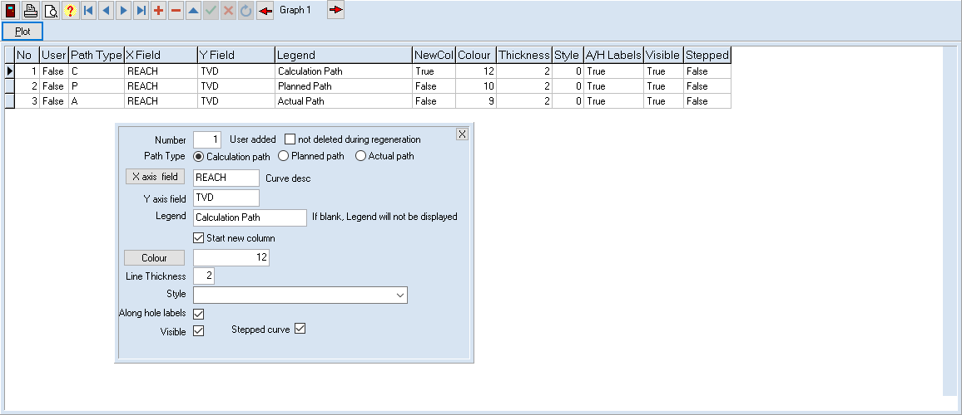

Each curve is defined by the path type and the X and Y fields being plotted.

The legend text and whether a new legend column is started are entered next.

Its appearance is defined by the colour style and thickness of the line used.

Along hole labels can also be added.

Plots can be displayed using the [Plot] button on either the header or the Curve table screen.

## Displaying Path Plots

The path plot form not only displays the plot but allows it to be modified and exported.

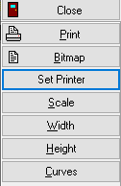 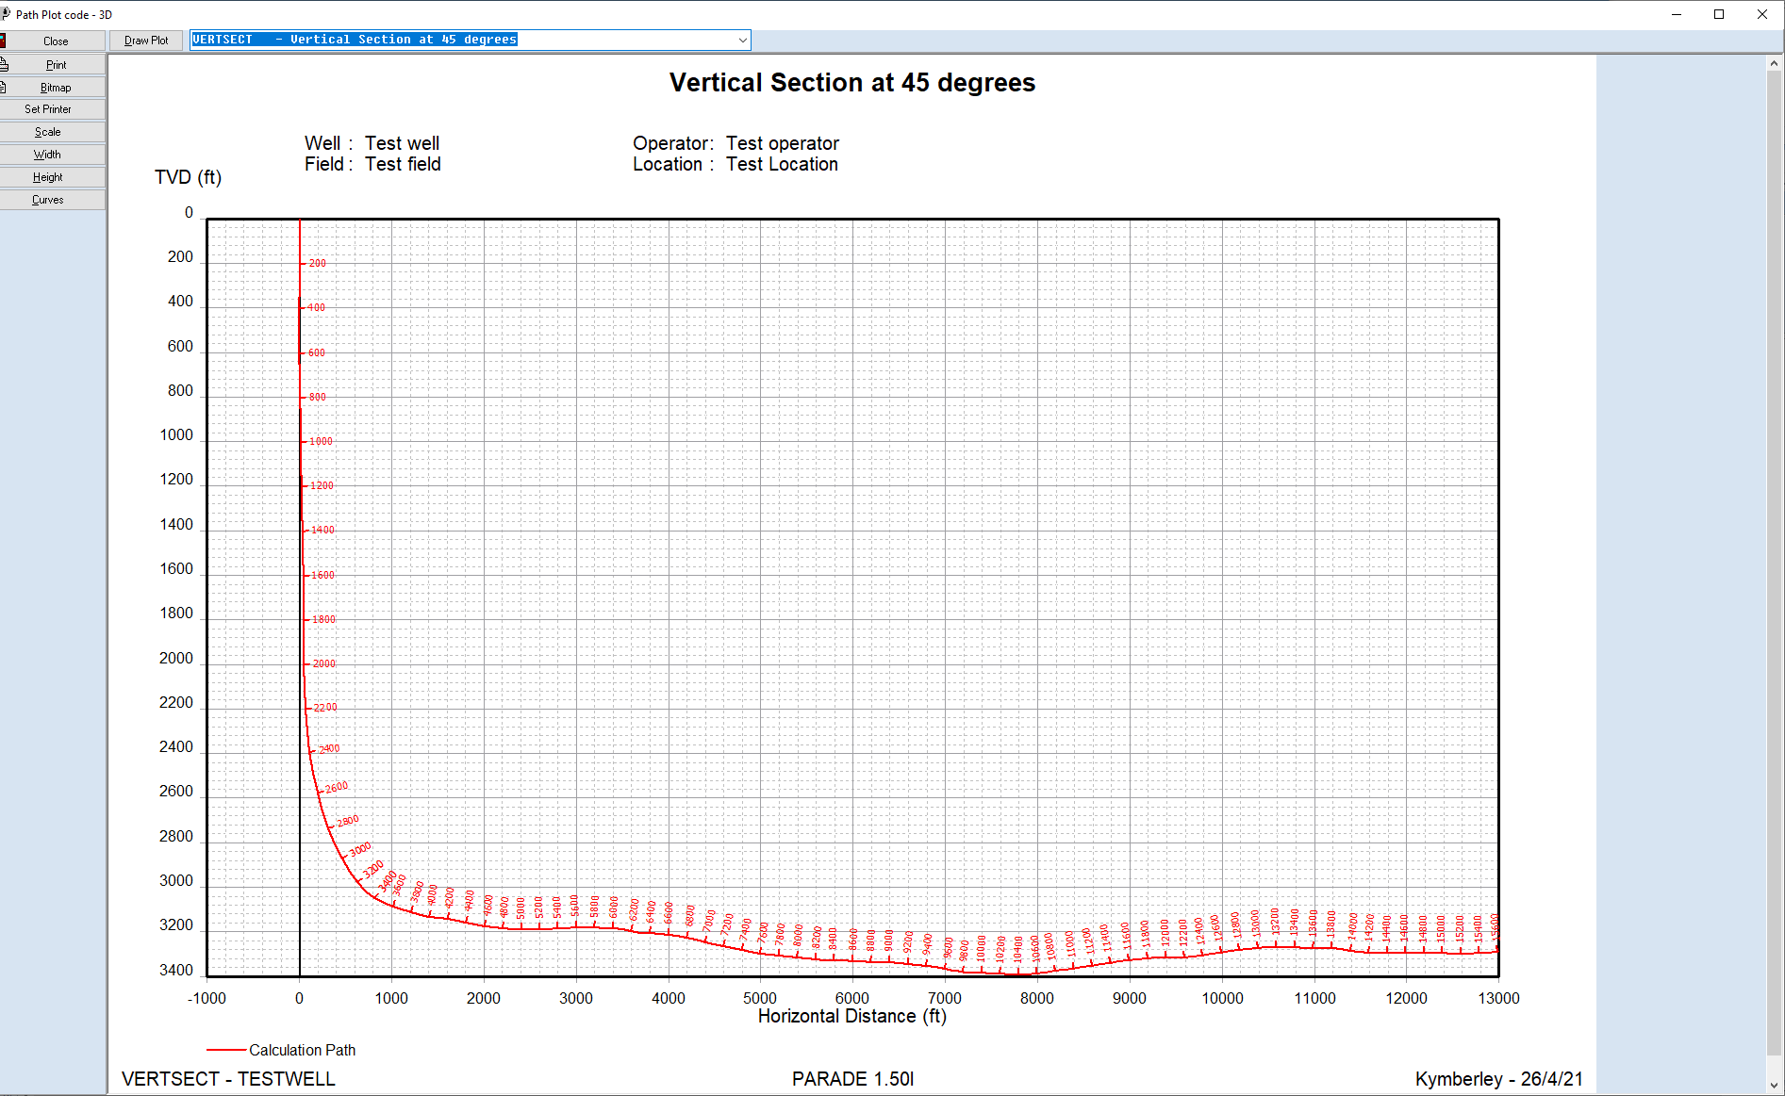

The current plot is selected in the Dropdown combo box above the drawing area. This can be used to select another plot. The [Draw Plot] button is used to redraw the current or newly selected plot.

The side buttons have the following functionality.

Close Closes the plot window

Print Prints the plot on the current printer

Bitmap Creates a bitmap file or saves the plot to the clipboard to paste into another application, eg a Word document. The file formats available are Bitmap (BMP), Jpeg (JPG) and Portable Network Graphics (PNG)

Set Printer Allows a different printer to be selected for printing

Scale Displays a pop up form that allows the orientation and scaling to be changed

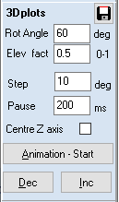Width Redraws the plot so it fits the width of the drawing area

Height Redraws to fit the drawing area height

Curves Displays the curves edit form for the plot

When a 3D plot is displayed, there is a parameter change and animation option for 3D curves.

The rotation angle and elevation factors can be changed and the plot can then be redrawn from a different perspective. This can also be saved for future plots, otherwise the original values will be used next time the plot is opened.

It is also possible to do an animation of the curve rotating about the vertical access.

The change in angle between each plot and a pause length between redraws are specified.

The new plots can be manually stepped through or automated.

It is usually advisable to centre the Z axis to prevent the plot wandering from one side of the drawing area to the other.

### Scaling

The scaling dialog allows the plot header and graph parameters to be changed.

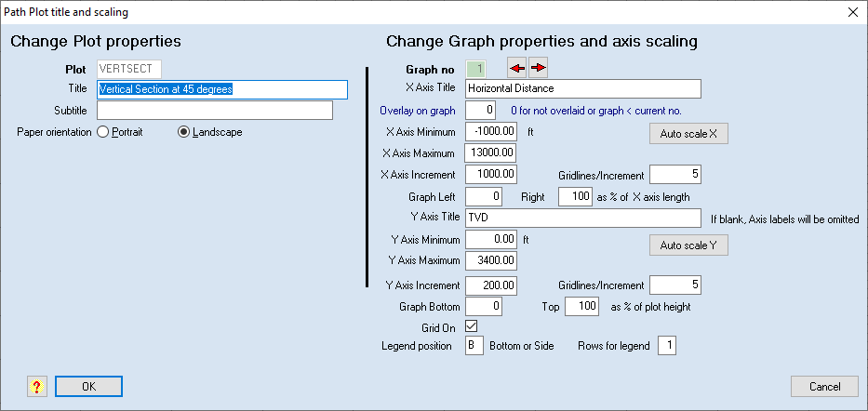

The header titles and orientation can be changed.

For the selected graph, the axis titles scaling and grid can be changed.

Clicking on the Auto scale buttons will set Minimum, maximum and increment to -999 and these values will be calculated when the plot is redrawn.

Once the dialog closes the plot will be re-drawn with the new parameters.

# Depth Plots

Depth plots display a select parameter on the X axis and measured (along hole) depth on the Y axis, with depth increasing in the downward direction.

These are generally created as part of the calculations and there are a fixed set of plots created for each calculation type, for each risk factor and defined on the calculation tab in the Scenario definition. Eg for Hydraulics

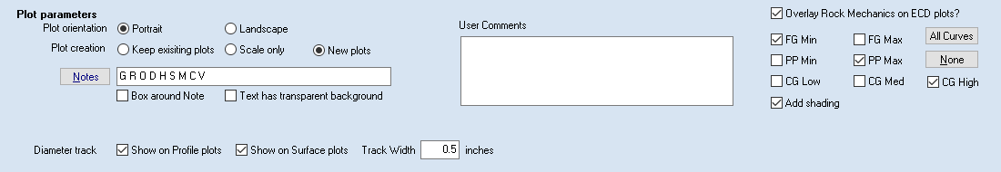

The **orientation** is selected, as well as default **notes**, overlays etc.

If the plot does not exist, it will be created. If it already exists it will be retained, rescaled or replaced depending on the selection for **Plot creation**.

If you have made any manual changes to the appearance, eg changed colours added shading or notes then select either Keep or Rescale only, otherwise they will be lost.

If you want to translate the plots into another language, you must create new ones, by re-running the calculations, after checking the Translation box.

These standard plots can be viewed by clicking on the appropriate risk type and then the plot buttons on either the Plots tab of the Scenario form or the Plot selection form on the Graphics menu.

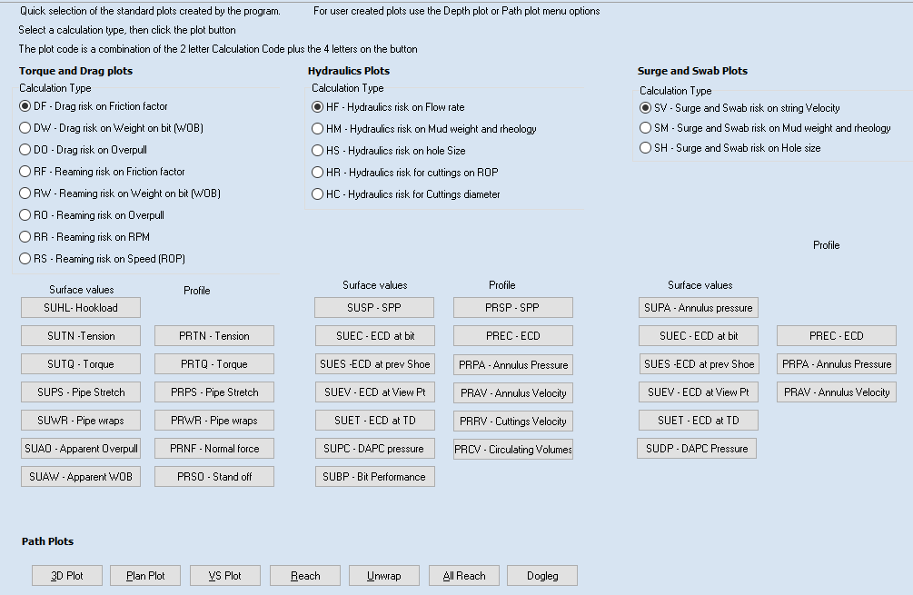

## Depth plot definition

Depth plots are defined in a set of 6 tables:

The Depth plot Header table (dplhdr.pxd) defines the plots, with the plot code as the index.

The Depth plot Graphs table (dplgph.pxd) defines the graphs for each plot, with the plot code and graph number as its index.

The Depth plot Curves table (dplcrv.pxd) defines the curves for each graph, with the plot code, graph number and curve number as its index.

The Depth plot Notes table (dplnot.pxd) defines the notes for each graph, with the plot code, graph number and note number as its index.

The Depth plot Lines table (dpllin.pxd) defines the lines for each graph, with the plot code, graph number and line number as its index.

The Depth plot Shading table (dplshd.pxd) defines the shading for each graph, with the plot code, graph number and shading number as its index.

These definitions can be accessed using the Depth plots Option on the Graphics Menu.

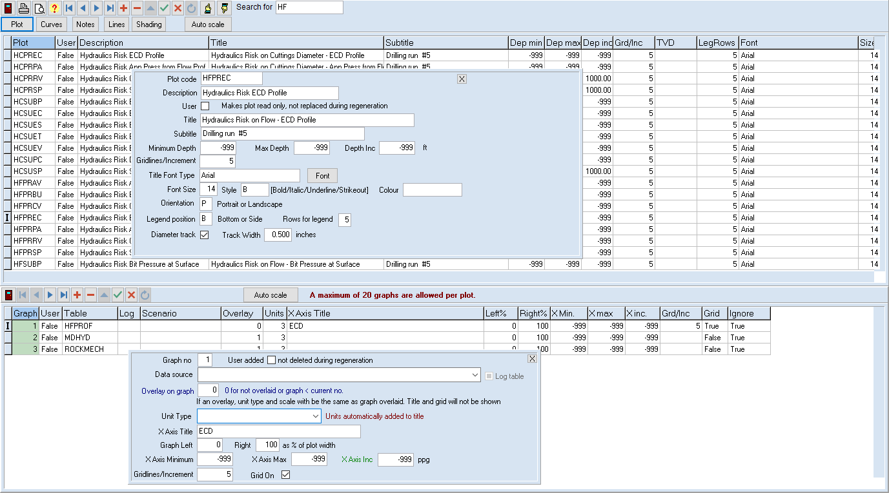

The top grid displays all the header records. The bottom grid displays only the graphs for the plot selected in the top grid. The buttons with hands pointing up and down are used to change the size of the bottom grid.

The header table defines the plot code and its description for identifying each plot.

The title and subtitle actually appear on the plot and there are options to change the font used for the title and the orientation of the plot.

The Y axis always displays Measured depth and uses 100% of the plotting area. The minimum and maximum values can be defined as well as the label increments. If -999 is entered for these values, the plot will be rescaled to fit the data. The number of grid lines between labels is also defined.

The diameter track can be displayed at the right of the graph. This is a usually narrow track that displays the hole diameter and the diameter of the tubing and tool joint diameters for string elements.

Each plot has 1 or more graphs which are defined in the lower grid.

For most plots there is a single Graph using all the plotting area width.

Each graph can only display curves for fields from one table, and only fields that use the same unit. Ie you can’t display pressure and ECD curves on the same plot. However, fields from other tables can be overlaid.

Each graph has a number.

The source table is defined from a drop down of valid tables. This drop down includes the calculated curves followed by any depth based log curves.

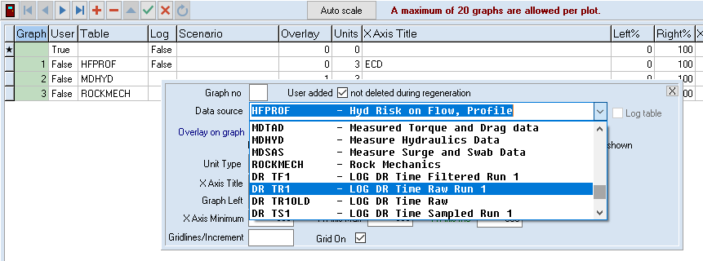

If the graph is to overlay another graph then the graph to be overlayed is entered otherwise it is 0. The graph number must be less than the current graph.

The unit type for the graph is selected. The unit description will automatically be added to the X axis title.

The graph left and right axis positions are defined as a % of the width of the plotting area.

The minimum and maximum X values can be defined as well as the label increments. If -999 is entered for these values, the plot will be rescaled to fit the data. The number of grid lines between labels is also defined. And the grid can be turned on or off.

Each graph can display the following graph types:

* Curves are plots of the values of fields in the selected source table
* Notes are lines of text
* Lines are straight lines
* Shading allows colouring of the area between curves and lines, including the axes or edges of the graph.

These are defined in separate tables which are displayed by clicking on the buttons at the top of the form.

The plot can also be displayed by clicking on the [Plot] button.



## Depth Plot Curves

Each graph may have a number of curves. The Red arrows are used to change to a different graph for the same plot.

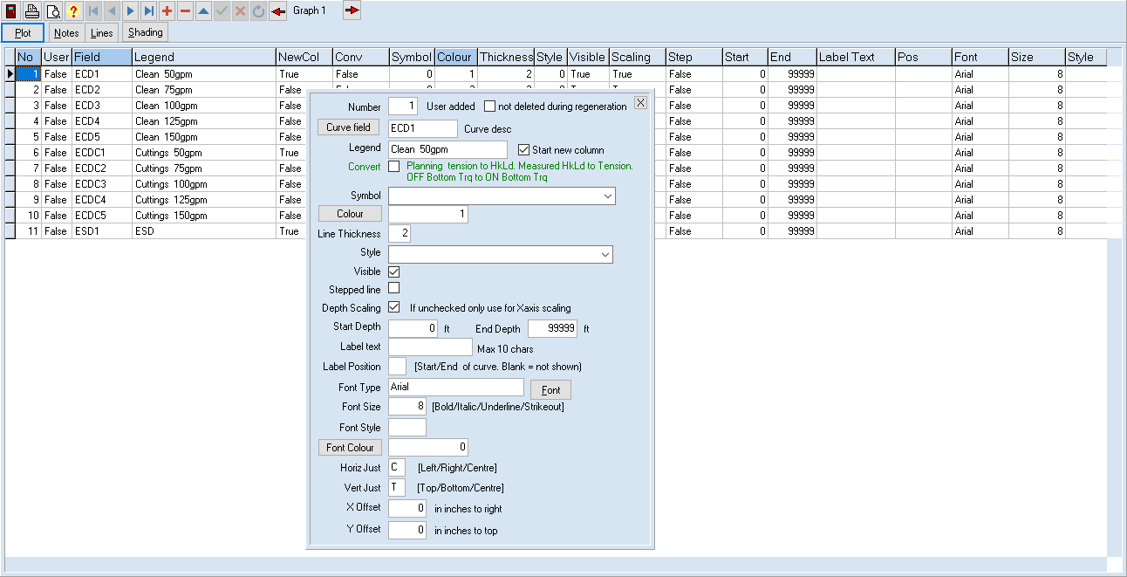

Curves are numbered and plotted in number order, which also determines the legend order.

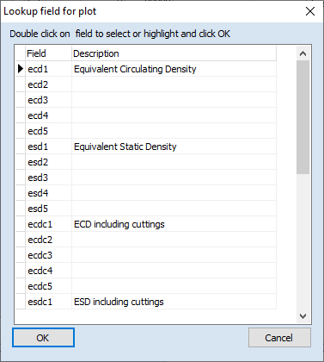Each curve represents a field in the source table. Clicking on   
[Curve field] will give a list of fields for the Graph’s unit type and allow one to be selected.

The legend usually includes the Risk factor as most curves are in sets of 5 for the different risk factors. You can also indicate if the legend is to start in a new column. If the legend is empty it will not be displayed, but the curve will still be plotted if visible.

The appearance of the curve is defined by colour, style and thickness.

You can also restrict the plotting of a field to a particular depth range.

The curves can be used in automatic depth scaling. Uncheck if the curve is not to be used. Eg a Rock mechanics curve may have a range that exceeds the desired plot range.

It is possible to add labels at the start or end of a curve, eg to designate Friction Factors. The label position and font can be defined. If empty, no labels are printed.

## Depth Plot Notes

Notes can be displayed on a graph. These are multi-line text strings and can be automatically created during the calculation or added manually later.

As for other Depth plot tables each item is numbered and red arrows allow the graph being displayed to be changed.

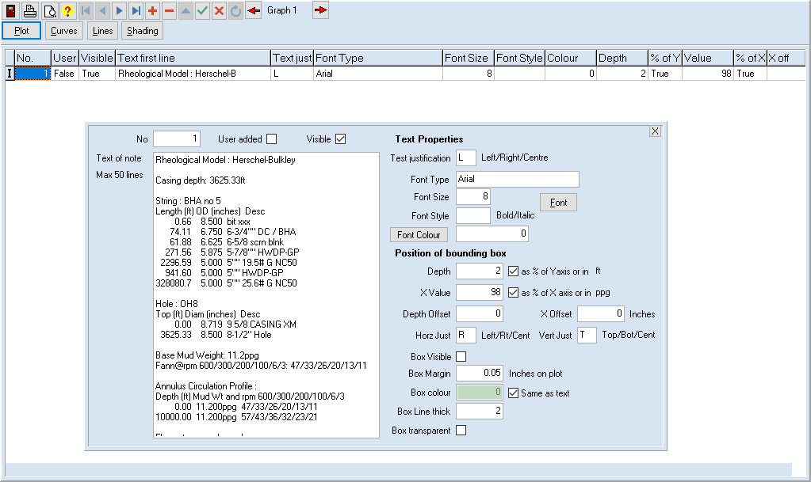

The lines of text are displayed, as well as the text justification and appearance.

A box can be drawn around the text and the background can be made White or transparent.

The position of the note can be defined as a % of the axis length or as a fixed value of the parameter being plotted. The % is useful for a general note while others may need to correspond to eg a specific depth. There can be an offset from the fixed position. The box margin colour and thickness can be defined.

Standard notes, as defined in the scenario tabs for each calculation type, are created and fixed at the time the plot is created. They display values from the input tables and parameters used in the calculation. They can be translated into another language but the calculation must be re-run with the translation box checked.

## Depth Plot Lines

Lines can also be added to plots. Examples of this may be strength or Torque limits, which are usually Vertical, or depth indicators which are usually Horizontal, although lines can be at any angle.

Lines are again numbered and other graphs can be selected.

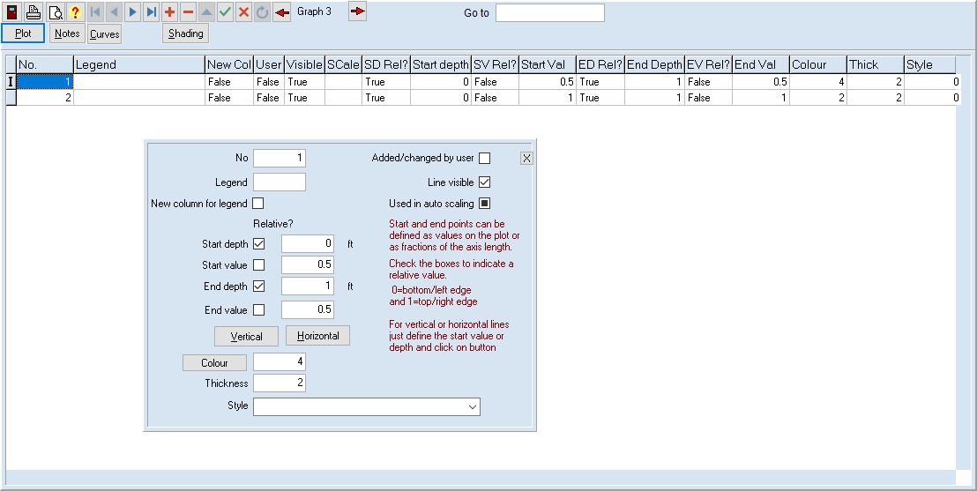

Lines can also have a legend defined, so they can be identified and, as for curves, can have that legend start a new column. They can also be used in depth scaling so the whole line is visible.

The start and end of each line can be defined as values or % of the axis length.

For example, for a limit the Y range would be from 0 to 100% of the Y axis while both ends of the line would have the same fixed X value. A horizontal line could be used to define a formation top. In this case the X values are 0 and 100% of the axis length and both Y values are the actual depth.

If the start X or Y value is entered a full length Vertical or Horizontal line can be quickly defined by clicking on the buttons.

The appearance of the line can then be defined.

If the legend is empty, it is not displayed. This may be used, for example, when the line is one of the limits for shading and the legend is attached to the shading.

## Depth Plot Shading

It is possible to shade parts of the plot. This can highlight danger areas, eg for buckling limits or Rock mechanics limits.

Shading records are numbered and graphs can be changed with the red arrows.

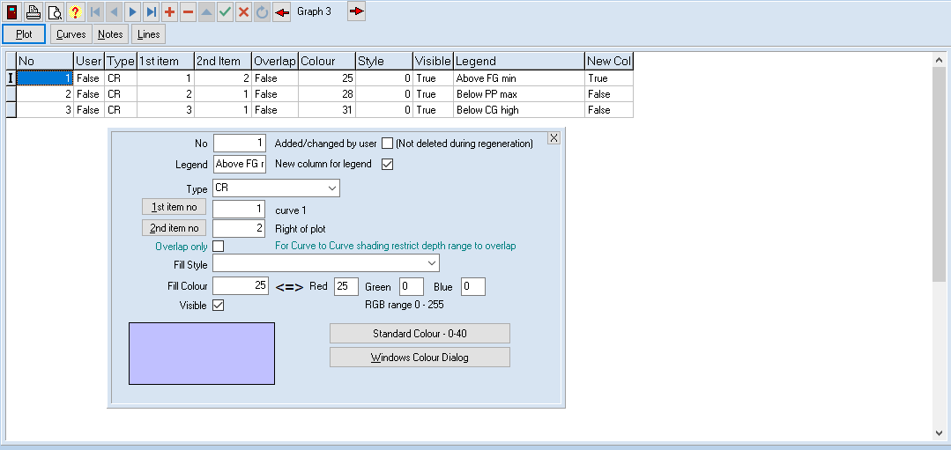

A legend and new column are defined. All shading is drawn before any other items in a plot and hence are the first legends to be displayed.

The type of shading is then defined one of CC, CL, CR, LL, LR or RR

The first letter defines the first item type and the second letter the second type, where C=Curve, L=line and R=reference.

The [1st item no] and [2nd item no] buttons allows these to be selected from a list.

For Curves and lines this is simply the number of the item for the graph. For a Reference it is one of a pre-set number of choices, the edges of the plot or an axis.

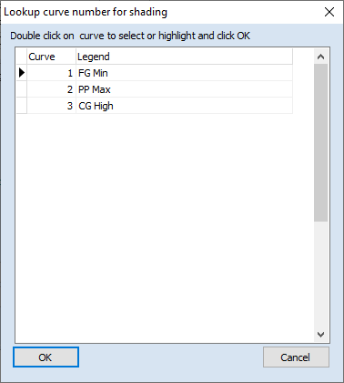 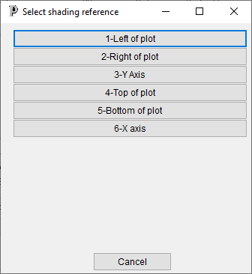

The shading can be a solid colour or hatching.

The fill styles are select from a drop down.

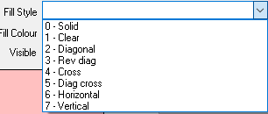

The colour can be entered as a standard colour or using RBG components. Each of these has a dialog for selection, which are displayed by clicking the corresponding button.

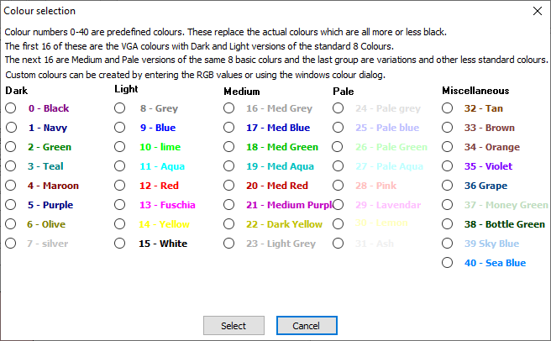 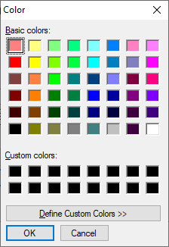

## Displaying Depth Plots

The depth plot screen not only displays the plot but has a number of options to manipulate and export it.

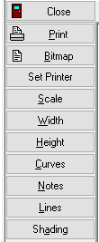 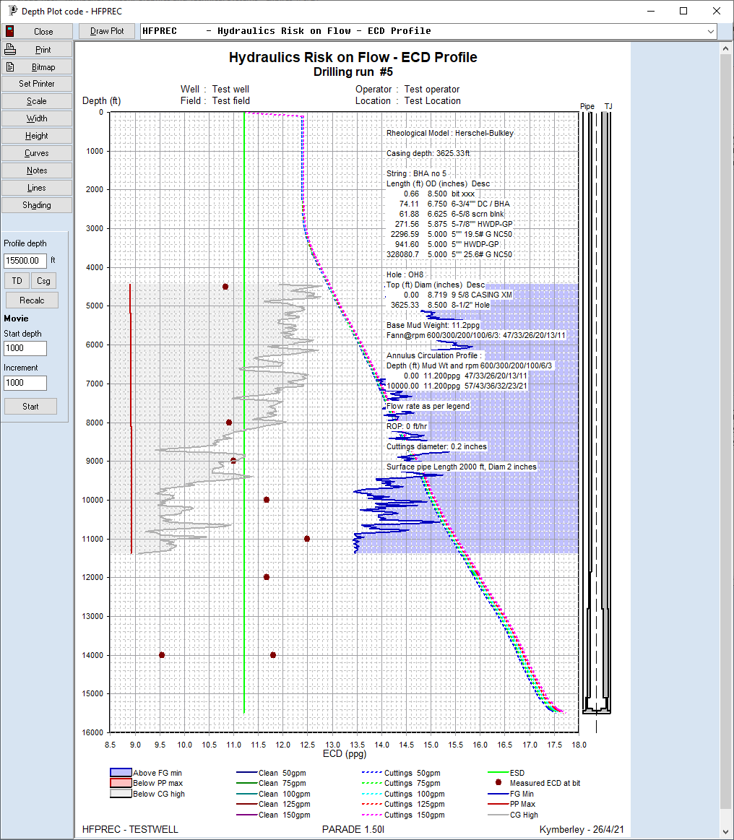

The current plot is selected in the Dropdown combo box above the drawing area. This can be used to select another plot. The [Draw Plot] button is used to redraw the current or newly selected plot.

The side buttons have the following functionality.

Close Closes the plot window

Print Prints the plot on the current printer

Bitmap Creates a bitmap file or saves the plot to the clipboard to paste into another application, eg a Word document. The file formats available are Bitmap (BMP), Jpeg (JPG) and Portable Network Graphics (PNG)

Set Printer Allows a different printer to be selected for printing. This could be used to export to a PDF file.

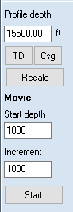Scale Displays a pop up form that allows the orientation and scaling to be changed

Width Redraws the plot so it fits the width of the drawing area

Height Redraws to fit the drawing area height

Curves Displays the curves edit form for the plot

Notes Displays the notes edit form for the plot

Shading Displays the shading edit form

In addition, for a plot of profile data, there is a panel which allows the depth of the bit to be changed. After a recalculation, the plot will be drawn with the new profile. Buttons are aused to set the depth to TD or previous casing depth.

The Movie option results in multiple profile recalculations and redraws based on the starting depth and the increment.

### Scaling

The scaling dialog allows some of the plot header and graph values to be changed.

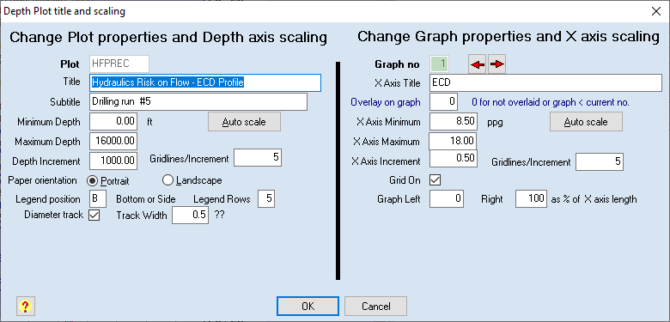

For the plot, the titles and scaling can be changed. “-999” means to rescale that value and the [Auto scale] button will enter -999 values, minimum maximum and increment.

Orientation, legend parameters and the string labels can also be changed and the diameter track can be turned on or off and its width can be changed.

Likewise, some graph parameters can be changed and again the graph can be changed with the red arrows.

Titles, scaling, grid properties and position are able to be changed.

Once the dialog closes the plot will be redrawn with the new parameters.